Global Savings Glut:

Inequality, Domestic Asset Markets, and Economic Growth

Rhodes Kirkpatrick

**Introduction:**

Savings and debt, or inequality are at all-time highs in both the world and in the United States. We know that some inequality is a good incentive for people to move into the production of higher utility goods and services. However, with the recent decades bringing the distribution of wealth to a lopsided 11:1 for the average vs. median family in the United States, is there an economic reason why at a certain point inequality generalizes into a broader issue?

From this macro vantage point, we can see two massive peaks in the economy, completely polarized from each other. One gets most of the attention and most people get acquainted with it personally. There is a long shadow of debt cast down upon governments, consumers, students, and corporations, and indeed it is scary, but the other peak which could vanquish its other stands slightly higher as savings and net wealth separate into a separate pile. Our financial sector takes value from the future to create value in the present, and this creates the necessity of cash flows to replenish the lines of credit and stay solvent. While this other peak of savings could be used to invest in order to create those returns necessary to pay off the debt and create more productivity, it is sitting idling in accounts, slushy assets, and visible wealth. Imagine the economy as a pile of cash in different areas. Institutions are the pipelines (including fiscal policy), and monetary policy changes the aggregate. What we are seeing in the economy now is a massive pile of cash savings (including short-term money market and mutual funds) hoarded overseas and in capital markets and not being introduced back into the pipelines as productive investment.

The idea of a global savings glut is not new. Economists such as Karl Marx, JA Hobson, and John Maynard Keynes all focused very intently on its consequences on growth. Economists such as Ben Bernanke point to the idea as an explanation of the 2008 financial crisis and the long-term decline of interest rates. Even though there is no formal or unified definition, I will be defining the Global Savings Glut as**The phenomena at which net savings surpass domestic net investment such that the proportion of money that is dead causes inflation in capital markets and lowers overall growth reflected in long term interest rates**. "Dead" is defined as "cash or allocated capital towards consumption from debt or passive incomes." Nevertheless, why does this happen, and what are the effects? We will look at empirical evidence linking inequality to giant sums of cash hoarding, how this affects human behavior, and what it means long term for growth and short and long-run welfare in society. Specifically, we will look at the global impacts on the United States domestic economy, where all the factors I describe will converge.

**Savings vs. Investment Preferences**

Both the National Income and Product Accounts and household wealth reported in the Financial Accounts of the Federal Reserve point to an increase in the savings rate by the 1% of 3% between the 1970s and post-2000[1]. This increase is substantial as savings surpassed net domestic investment in 2000, and most of these savings show themselves in financial markets[2]. The general perception is that financial markets allocate resources efficiently into investments. However, the evidence as shown in **The Savings Glut of the Rich** by Straub, Sufi, Mian[3], identifies that after removing intermediaries and looking at the US Financial Accounts, almost 2/3 of the rise in asset accumulation by the top 1% has gone into claims against government and household debt. Using a panel of states to control for financial deregulation, wages paid by employers, tax incentives, and pre-trends, the evidence shows that increases in top income-earning are consistent with an increased desire to save. This relationship between macroeconomics and the financial sector is puzzling. If investment is decreasing and governments and the bottom 90% are deeper in debt, then is the non-production of the financial sector leading to any long-term detriments?

An important question to ask however, is how the bottom 90% of income earners get in such large debt? Cynamon and Fazzari[4] show that rising inequality starting in the 1980s forced the bottom 90% to either cut consumption or borrow further to negate short-term payments owed on their balance sheets. With the subsequent boom in household debt levels until the Great Recession, we see that they chose the latter. Since then, real household demand has grown at the same pace as the pre-recession trend. However, at a difference in the intercept of about 1.5 trillion 2009 dollars and noted that into 2015 it still held[5]. Suppose we assume that recessions are indeed temporary. In that case, this persistent deficit below potential gives cracks to the idea that long-term economic growth is mainly determined by long-run aggregate supply. With household debt increasing even more substantially with growing inequality, we must conclude that the availability of debt financing is convincing by itself for consumers to keep their optimal level of consumption. We see that inequality is forcing either austerity or increasingly volatile cycles of debt.

Household debt is again at an all-time peak (pre-COVID). With still stagnant wages, there is no natural increase in purchasing power except that the drop in interest rates have allowed the eventual re-payment schedule of debt to the extent in the future. To re-iterate, too few people have too many savings, causing a demand drag on the entire middle and lower class by hindering the demand generation process. The historical trend of inequality could be disrupting the economy via circular flow because higher incomes have a lower propensity to consume. There is a vicious cycle here as lower demand lowers incentive for investment and lower investment leads to less demand.

However, Cynamon and Fazzari note that the timing tells a different story. With income inequality rising in the 1980s, household demand to cash ratio did not decline; however, the simple interpretation at face value does not include financial dynamics. With the massive amount of borrowing available, as discussed in Straub, Amir, and Mian's work, the savings glut can postpone unsustainable trends. Cynamon and Fazzari use a panel to assess the effect of income distributions on the Keynesian Multiplier and find that the US could be around 10% or more below potential if the income distribution followed the trends in the 1960s-1970s [6].

The increase in inequality is not only attributed to domestic United States economic activity. The increase in savings by the 1% in, mainly, oil nations and emerging Asian markets, has caused massive amounts of capital flows into the United States, financing the capital account and external deficit. Using the FRED database, we see that net capital flows are 0 until the 80's where it starts increasing linearly from 0 to about a max of 111 billion dollars in 1995. From there, it reaches a peak of 726 billion dollars right before the financial crash and has since been increasing again with a weighted average of about 200 billion dollars since the trough[7]. The US and China's capital accounts were almost mirrored until the early 2010s where demand from other countries started soaring. Indeed, Bertaut, DeMarco, Kamin, and Tyron[8] show that selling of portfolio debt has made up the bulk of the financing of the US current account deficit and that agency backed (Government guaranteed). Corporate bonds have been sold to large institutional investors, again confirming that the global 1% are using their savings to finance household and government borrowing in the United States. As they further examine in their paper, the rise of surplus funds into the United States was exogenous, independent of financial developments, thus re-enforcing the case that these surplus funds were responsible for decreasing interest rates. In fact, they find using an OLS regression that builds off Warnock and Warnock (2009) using outstanding US Treasuries and Agencies data from June 2007, that a 100 billion dollar increase in the official foreign inflows decreases treasury yields by 11 basis points. Using a panel of similar studies, we can confirm their findings are in a consistent range[9].

Now that the consumer story has been told, let’s shift to the corporate debt side. As discussed, prior, before the Great Recession, foreign capital inflows were going almost entirely into agency-backed securities, primarily mortgage-backed securities (MBS) and US Treasury Bills[10]. As mentioned, the increase in financing by the US 1% and the massive increase in savings globally drove down interest rates; however, the saving countries (Emerging Asia and Oil nations) that poured their savings into the United States did not expect to end up in risky investment at all. Bernanke et al. l, 2011, explains how because all these funds were directed into fixed income securities, the yield on safe assets decreased so much that private investors started demanding alternative investments to match historical expectations. In fact, the reason why European institutions ended up with much of the private-labeled asset-backed securities (ABS) is that the emerging Asian countries and oil exporters took most of the Agency-backed securities off the market for which the increase in supply could only make up for marginally. On the eve of the first financial crash during the Great Recession, the share of foreign holdings of agency-backed securities was at 31%, and ABSs were at 24%. Out of Corporate bonds held by foreigners, nearly half were securitized into ABSs. Out of the non-ABS holdings, a majority were in alternative assets such as structured cash flows, floating-rate notes, and financial debt obligations[11]. The risk appetite manifested itself through these financial intermediaries being compensated for high yields but not penalized for tail risk when the eventual crash happened.[12] Essentially the boom in foreign funds into the US had to go into a specific sector. Because of easy financing through the 1% of the US mixed with the need for assets abroad and the government's deregulation of the financial sector, subprime lending created the perfect mix of an American debt trap fueling the global asset market.

**Net Household and Government Debt Positions**

Not only have the bottom 90% started borrowing more since the 1980s, but they have also reduced asset accumulation that is a direct claim on other's borrowing. In Straub's research, he measures household debt position between the wealthy groups over time and concludes that at the peak before the Great Recession, the top 1% was owed a net 12% of GNP, while the bottom 90% owed 39% of GNP[13]. They also include multiple approaches to confirm robustness. Straub, Sufi, and Mian identified that 30% of GNP owed from the bottom 90% were financed by the top 1% in their research. Through financial unveiling, their finding for the 3% average increase in government and household debt by year is that the top 1% owns 1.7% in the United States and 2% is owned by the rest of the world (3.7%-debt owed by the bottom 90% to the government equals 3%)[14]. Now we conclude that there is no question that an increase in savings by the American 1% has been mirrored by dissaving's by the bottom 90% and the government. Straub, Sufi, and Mian's state-level analysis allow us to confirm that the increase in top income shares has been accompanied by an increased propensity to save. This research shows an increase in income inequality has wholly transformed the level of wealth inequality, which links low-interest rates to indebtedness, as Cynamon and Fazzari explained in their paper.

**Cash Hoarding, Returns to Capital, and the Billionaires Jet:**

Recessions are caused by a mix of debt and bad or lack of investments. Like we saw in the Great Recession, hoarding of Agency Debt caused yields to drop and prices to skyrocket, but the underlying fact is that the money had nowhere better to go. This is called a **Misguided Market**, where essentially, the demand for returns diverges the price of an asset from its utility provided. In these scenarios, genuinely good investments dry up, and when banks only provide a small interest rate, demand for securities shoots through the roof. While we have seen the cash ratio for the SP500 double since the early 2000s from around 9% to 18%, the Capex (percentage of capital expenditures as a percent of GDP) has declined by 3%[15] since the 1970s, mirroring almost exactly the increase in savings by the American 1%.

To show how the strong desire drives the activity, we can take a look at two great quasi-natural experiments. The 2004 American Jobs Creation Act allowed a significant tax cut on foreign repatriated cash, and the Tax Cut and Jobs Act similarly approached the problem. These two experiments show the effect of attempted persuasion to introduce more cash into the economy exogenously and its effects on domestic investment and GDP growth. Clausing (2005) notes that firms were able to take advantage of the tax cut by only pursuing projects they had already intended on and then shifted almost all other cash to dividends and share buybacks[16] and Dharmapala estimated that less than one cent on every dollar was reinvested[17]. Many would think that at least in the future, more funds could be deployed domestically. However, Dharmapala addresses directly how the expectation of future repatriation deals from the government caused more hoarding overseas than before. In other words, a classic solution posed to the problem of cash hoarding fails because executives expect to be alive to reap the benefits of the next repatriation deal. The situation enlightens us to the motivations underlying the phenomena of the global savings glut itself. The return on a big tax break at an uncertain time in the future provides higher utility than any large-scale investment they could make today.

In the last ten years, we have seen a total of 4.18 trillion dollars of share buybacks. This has manifested itself in a 65% increase in the sp500 since 2017; even amid the coronavirus, the stock market continues to soar with the flush of money put in. The problem, of course, is that a staggering amount of the market cap in the stock market does not even plan to turn a profit, like Amazon, Uber, and many technology companies. In fact, according to initial public offering (IPO) data compiled by Jay Ritter, in 2019, 78% of IPO listings did not turn a profit, and this is trending upwards, compared to a decade average of 32%[18]. If the large piles of cash cannot even fund companies at the tune of billions of dollars per year to profitability in the near future, then it is a reasonable conclusion that we should ask if using our resources on these companies is better spent than demand generating wealth redistribution programs. If there are fewer and less profitable investment opportunities, when the next Uber or Airbnb comes onto the market, the ultra-wealthy investment institutions and billionaires are going to start a wild bidding war in the hope that it will be the next Amazon. Now the reader of this paper might have a genius widget invention or a new cupcake design that can turn a 500% profit in the first year with an investment of $10,000, but that measly $50,000 profit will not even cover the jet fuel it took to get to the pitch and back.

Even with much higher returns to capital of a small-scale project, we can see how this dilemma has an adverse effect on small businesses or local ideas as they get crowded out. The compounding effect of wealth plays out here to the advantage of large-scale business as according to the US's official "small business GDP" report[19], large businesses reported 2.5% of annualized growth vs. 1.4% for small business, in addition, the percent of small business relative to GDP fell from 48% to 43.5% in 2014. This correlation can be understood by revisiting the paper by Cynamon and Fazzari, who demonstrate the long-term demand strain on the economy caused by debt cycles. As small businesses do not have the cushion that large businesses have, the volatile debt cycles in the economy cause disruption over the long term and thus further consolidation. Therefore, we see that even with higher returns to scale because inequality has dragged down purchasing power at more regular rates, the small enterprise is disproportionally adversely affected.

**Conclusion**

The Global Savings Glut phenomenon is plaguing the United States with new problems for the developed nation. While savings is on the rise domestically, the bottom 90% of American's are forced to either borrow beyond their means or cut consumption dramatically. The effect on the economy is a lower marginal propensity to consume over the long run and a demand drag. The economy in the United States is trending in a favorable direction towards the wealthy and high income, and what we have seen over the past three-four decades is a 3% increase in savings preferences and a large stockpile of overseas money. Two-thirds of that money is being used to finance household and government debt, and it should be noted that the 17% or so savings rate for the US is misleading, as Straub, Amir, and Mian show. The bottom 90% are deeply in debt, and the wealth accumulation of the top is more considerable than we have ever seen. Global capital inflows pose new questions on how to cope with lower returns. As seen with the Great Recession, incentives can be perverse easily and, in Dharmapala's case, give light to how difficult it really is to get the cash that leaves the economy back. New questions need to be posed to the financial sector. It would be essential to assess their effectiveness in providing the best outcomes for the economy with the significant decline of net domestic investment. Prescriptively, higher taxes should be considered and are most likely necessary to make public investments as we have seen the equity markets fail to turn a profit in a surprisingly wide range of market capitalization. A major obstacle is that overpricing must be realized to re-proportion income distribution, or current inflationary trends will almost exclusively benefit the current wealthy.

**Journals:**

**1:**Mian, A., Straub, L., & Sufi, A. (2020). The Saving Glut of the Rich and the Rise in Household Debt. doi:10.3386/w26941

**2**: Bertaut, C., Demarco, L. P., Kamin, S., & Tryon, R. (2011). ABS Inflows to the United States and the Global Financial Crisis. doi:10.3386/w17350

**3**: Cynamon, Barry Z., and Steven M. Fazzari. "Rising Inequality, Demand, and Growth in the US Economy." SSRN Electronic Journal, 2015, doi:10.2139/ssrn.2570506.

**4:** Dharmapala, Dhammika & C. Fritz Foley & Kristin J. Forbes, 2011. Watch What I Do, Not What I Say: The Unintended Consequences of the Homeland Investment Act. Journal of Finance, American Finance Association, vol. 66(3), pages 753-787, June.

**References:**

1. Appendix [1]
2. Appendix [2]
3. Mian, A., Straub, L., & Sufi, A. (2020). The Saving Glut of the Rich and the Rise in Household Debt. doi:10.3386/w26941
4. Cynamon, Barry Z., and Steven M. Fazzari. "Rising Inequality, Demand, and Growth in the US Economy." SSRN Electronic Journal, 2015, doi:10.2139/ssrn.2570506.
5. Appendix [3]
6. Appendix [4]
7. https://fred.stlouisfed.org/series/BOPI
8. Bertaut, C., Demarco, L. P., Kamin, S., & Tryon, R. (2011). ABS Inflows to the United States and the Global Financial Crisis. doi:10.3386/w17350
9. Appendix [5]
10. Appendix [6]
11. Albertus, Bertaut, and Curcuru "Has the Crisis Changed Foreign Positions in US Securities?" Federal Reserve staff working paper 2010.
12. Kashap, Rajan, and Stein, 2008; Arteta et al., 2010
13. Appendix [7]
14. Appendix [8]
15. Brennan, P. (2020, July 01). US companies hoarding cash seen dragging on recovery until coronavirus beaten. Retrieved November 17, 2020, from: https://www.spglobal.com/marketintelligence/en/news-insights/latest-news-headlines/us-companies-hoarding-cash-seen-dragging-on-recovery-until-coronavirus-beaten-59263746
16. Clausing, K. (2005). Tax Holidays (and Other Escapes) in the American Jobs Creation Act. National Tax Journal, 58(3), 331-346. Retrieved from <http://www.jstor.org/stable/41790272>.
17. Dharmapala, Dhammika & C. Fritz Foley & Kristin J. Forbes, 2011. Watch What I Do, Not What I Say: The Unintended Consequences of the Homeland Investment Act. Journal of Finance, American Finance Association, vol. 66(3), pages 753-787, June.
18. https://site.warrington.ufl.edu/ritter/files/IPOs2019Statistics.pdf
19. Kobe, K. (2018, December). Small Business GDP 1998–2014. Retrieved from <https://cdn.advocacy.sba.gov/wp-content/uploads/2018/12/21060437/Small-Business-GDP-1998-2014.pdf>.

**Appendix:**

**[1]**

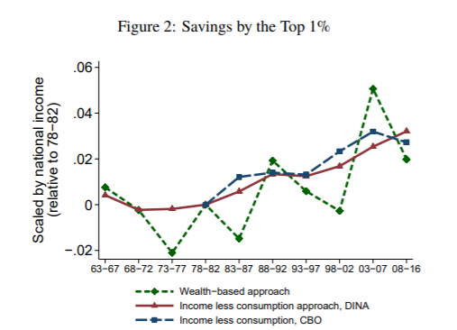

**[2]**

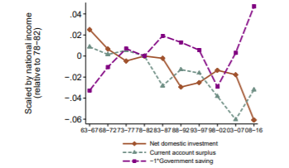

**[3]**

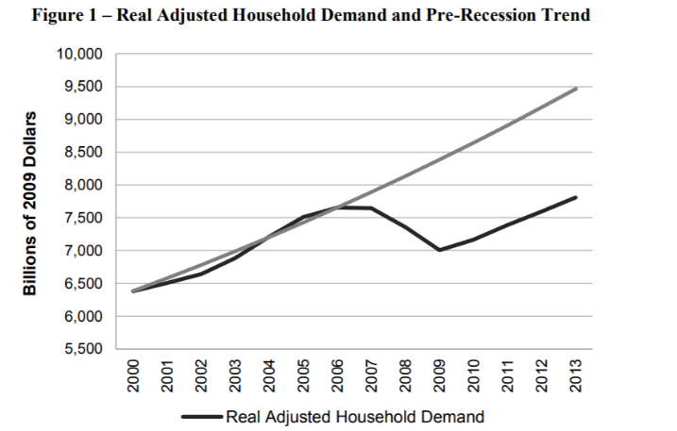

**[4]**

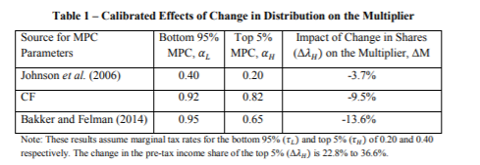

**[5]**

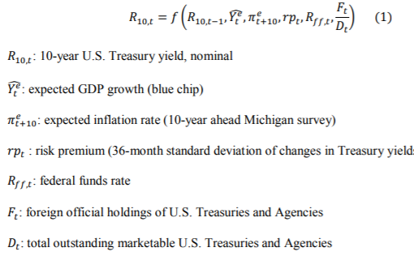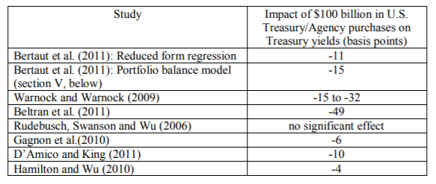

**[6]**

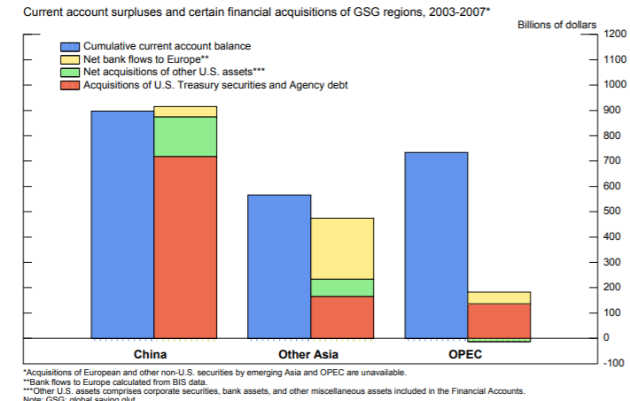

**[7]**

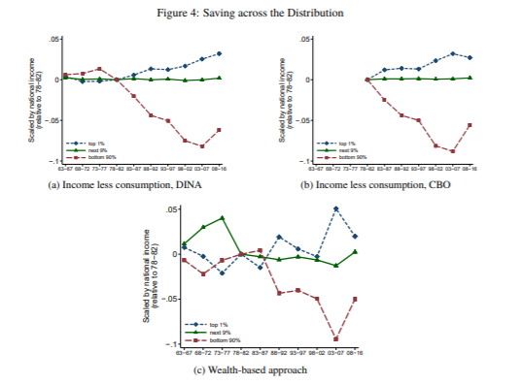

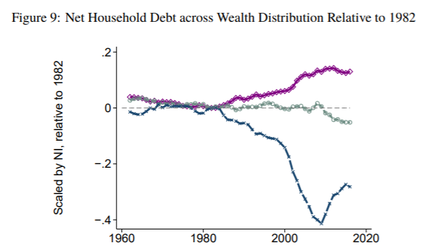

**[8]**

